# **Name: Abdurrahman Qureshi**

# **Roll No: 210451**

Practical No: 10

1. **Write a program to find the smallest numbers.**

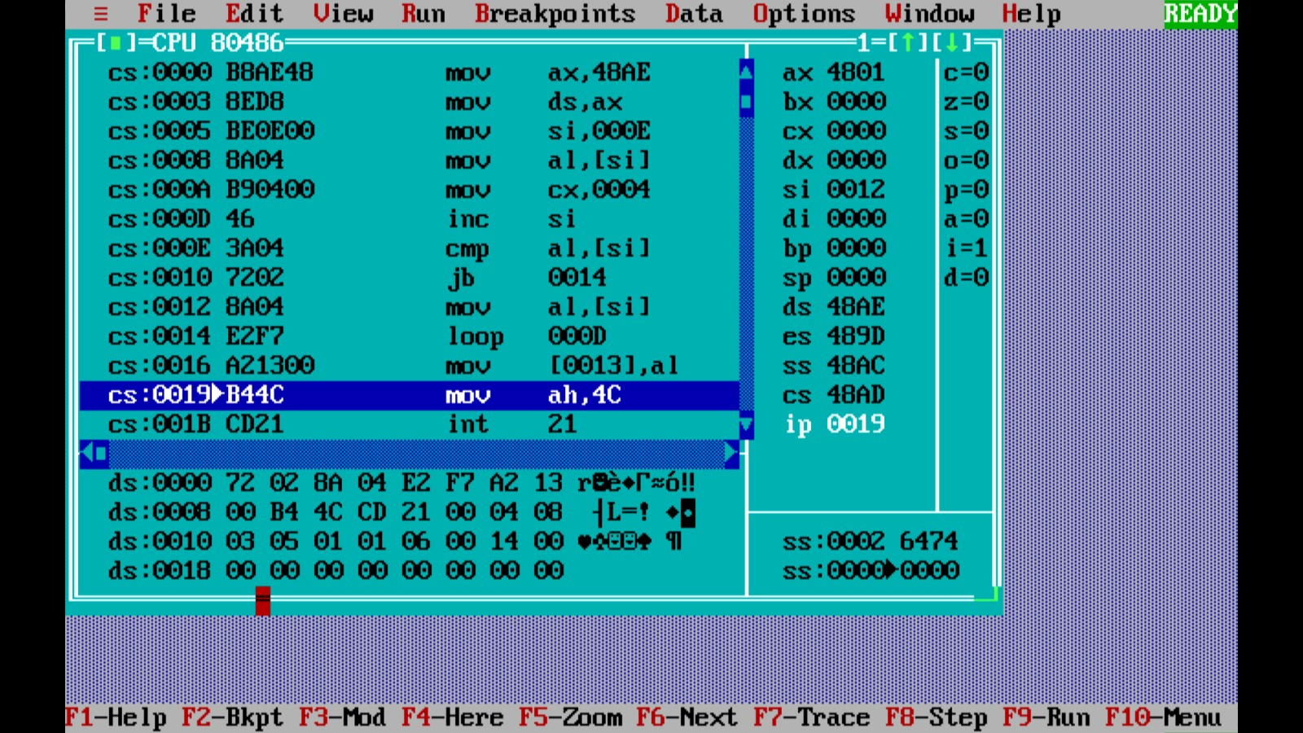**OUTPUT:**

1. 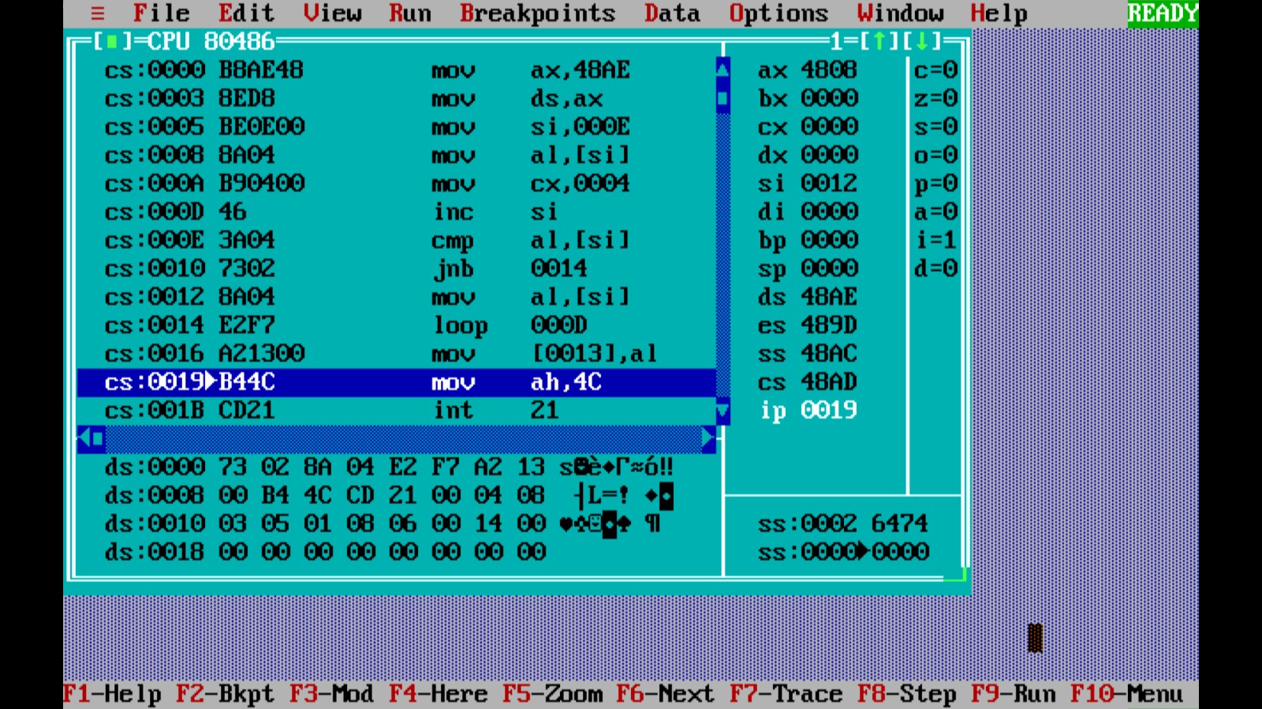**Write a program to find the greatest numbers.**

**OUTPUT:**